Schoology Set-up 2020-2021 For Students

Welcome to the new school year! This year, all students will be using Schoology for some or all class assignments. Use the steps below to set up and learn about Schoology.

Area | Description
Sign in | Sign in to Schoology from ClassLink. Go to:  - Polkschoolsfl.com  - Choose Students at the top of the page or in the 3-line menu at the top  - Choose CLassLink  Use the same sign in as you use for classroom computers.  See your teacher for help with signing in.
Profile | Set up your personal PROFILE. Your teacher and classmates will be able to see your profile.  Add a school appropriate picture or choose another avatar on that page.  All items added here must be school appropriate- See code of conduct for more details on images that are allowed in Polk County Schools.
Connect your document apps | Connecting your apps will make completing assignments easier.  Go to Resources (top of page) > Apps (left side)  Select Google Drive, then OneDrive. Sign in to each using the same information you  used to sign in to Schoology.
Courses | Your classes will automatically be added to your Schoology page.  Click Courses at the top of the page.  Click this link to learn how to Reorder your courses. A great way to organize them is  to put them in order of the class periods you have that class.
Navigating Schoology  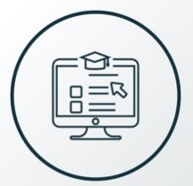 | Find the following items on your Schoology Home page:  Click on a course and find:  Materials- these are all the resources and activities for the class.  Updates- Your teacher will post important messages for your course here.  Gradebook- Your grades for each Schoology assignment are in this area.  Messages (envelope)- Here you will find all direct messages from your teachers.  Notifications (bell)- All course changes and grade updates will be listed here.
Course Welcome/ Information folder.  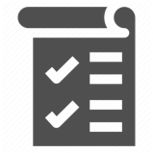 | Look in your course(s). See if you have a folder with your course information.  Check for these items in this folder:  How to contact your teacher.  What are the class expectations?  How can you get help in this class?  What other important information does your teacher want you to know about this  course?
Additional Resources | - Getting Started for students  - Students and Parents PCPS Schoology FAQ’s; See also Parent Tech Resources  - Support Phone line: 863-733-0331, Choose option 2 (Parents and Students)

